EXPERIMENT NO. 05
IMPLEMENTATION AND ANALYSIS OF SR LATCH USING STATIC CMOS
―――――――――――――――――――――――――――――――――――――――――――――――――――――――
AIM
To implement and analyze an SR Latch using static CMOS design style in LT Spice.
SOFTWARE USED
LT Spice
CIRCUIT DIAGRAM
Logic diagrams and transistor-level schematics for NOR and NAND based SR latches:
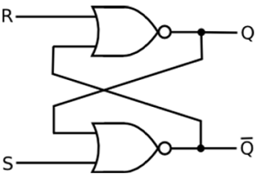
Figure 5.1: Gate-Level Schematic of NOR-Based SR Latch
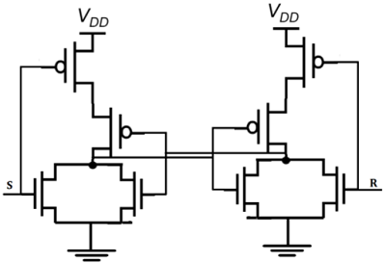
Figure 5.2: CMOS Transistor-Level NOR SR Latch Circuit
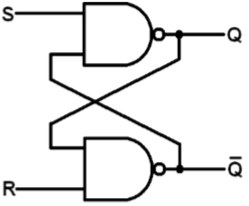
Figure 5.3: Gate-Level Schematic of NAND-Based SR Latch
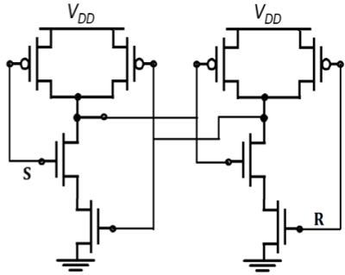
Figure 5.4: CMOS Transistor-Level NAND SR Latch Circuit
Complete simulation circuit schematic in LT Spice:
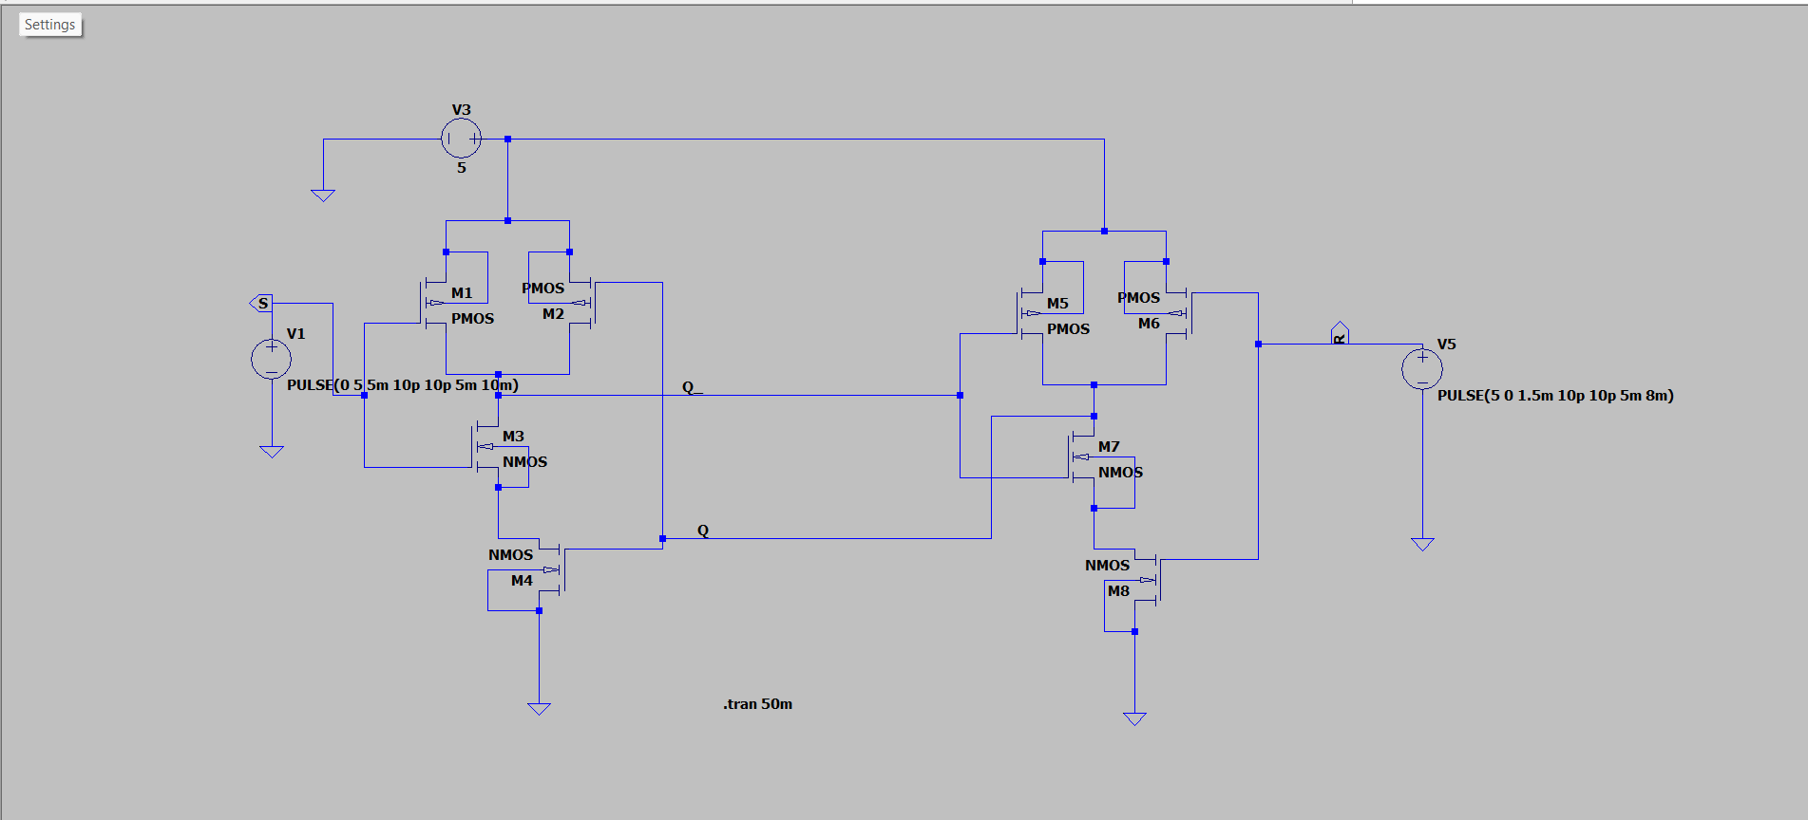
Figure 5.5: LT Spice Schematic of Static CMOS SR Latch
SMALL THEORY
An SR (Set-Reset) latch is a basic bi-stable sequential memory element capable of storing one bit of binary data using cross-coupled inverting feedback.
1. NOR-Based SR Latch Operation:
- S = 1, R = 0 (SET): Sets output Q = 1 and Q' = 0.
- S = 0, R = 1 (RESET): Resets output Q = 0 and Q' = 1.
- S = 0, R = 0 (HOLD): Both outputs retain their previous states (Memory / Hold condition).
- S = 1, R = 1 (FORBIDDEN): Forces both Q and Q' to 0 simultaneously, violating complementarity. This is an invalid/forbidden condition.
Truth Table for NOR-Based SR Latch:
S | R | Q | Q' | Operation / State
0 | 0 | Q_prev | Q'_prev | Hold (No Change)
1 | 0 | 1 | 0 | Set
0 | 1 | 0 | 1 | Reset
1 | 1 | 0 | 0 | Not Allowed (Invalid)

2. NAND-Based SR Latch Operation:
- Active-Low Control: Operates with active-LOW control signals (S' and R'). S' = 0 sets the latch (Q = 1), R' = 0 resets the latch (Q = 0), S' = R' = 1 holds data, and S' = R' = 0 is forbidden.
Truth Table for NAND-Based SR Latch:
S' | R' | Q | Q' | Operation / State
1 | 1 | Q_prev | Q'_prev | Hold (No Change)
0 | 1 | 1 | 0 | Set
1 | 0 | 0 | 1 | Reset
0 | 0 | 1 | 1 | Invalid Condition

OUTPUT GRAPH
Transient simulation waveforms showing Set, Reset, and Hold transitions in LT Spice:
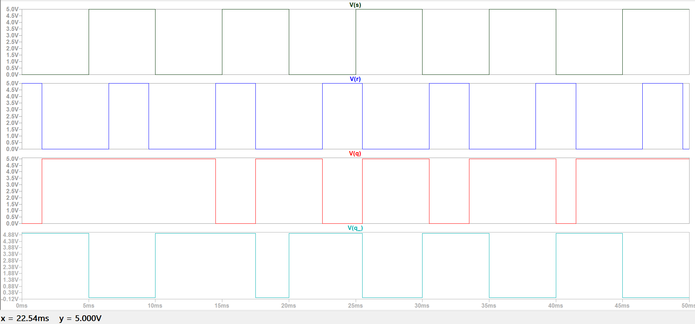
Figure 5.6: Transient Simulation Waveforms for Inputs V(s), V(r) and Outputs V(q), V(q_)

